École Campbelltown – October / November / December - Collage of News

We have been trying to keep families up to date on all the extra activities occurring in the school. We felt it would be important to share some photos and highlights of these whole school news events. Please understand it is hard to get all students in the photos as we must keep them in their cohorts.

Read-a-Thon

During the month of October / November, students worked hard at home reading to raise funds for the school. The students raised a total of $5130.76. For most funds raised, the winning classes were grade KMA, 1/2 G and 4G. Each of these classes was awarded a pizza party on behalf of school council. We want to thank school council for putting together this fundraiser and for each family that participated.

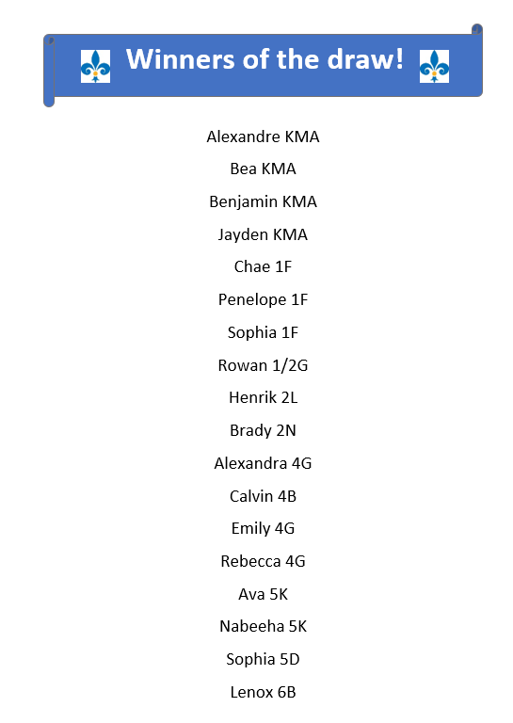 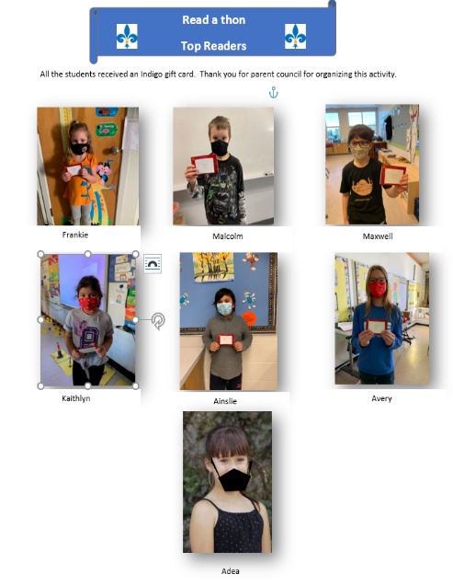

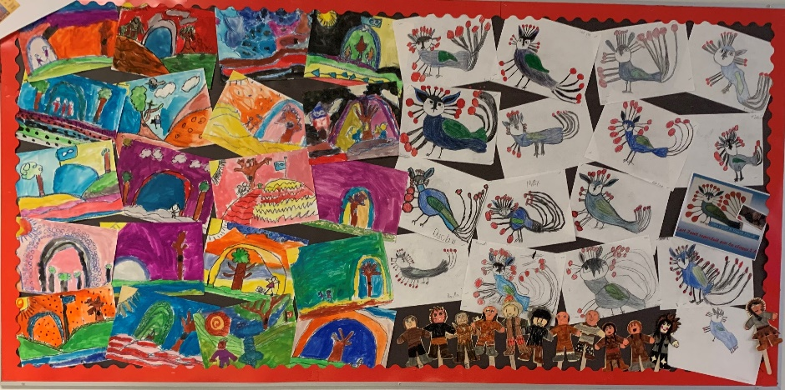

During Métis week students in grade 2 created artwork (on the left) like Métis artist Leah Dorian. The pictures on the right are based on Inuit art from Kenojuak Ashevak.

During Métis week, students also had Anti-Bullying programming that occurred. We had the group Saffron do some live online presentations with several of our classes.

On Remembrance Day we also challenged students to go home over the weekend and take a “moment of time” to recognize past and present military by sharing the videos posted on the website.

It has been challenging on trying to figure out new ways of staying connected throughout the school. So, in December we decided to have whole school theme weeks. We started out with Tacky Christmas Sweater week, then rolled into a week of giving where parents had the opportunity to donate to Campbelltown families in need and to also collect food bank donations. This week is Christmas hat week.

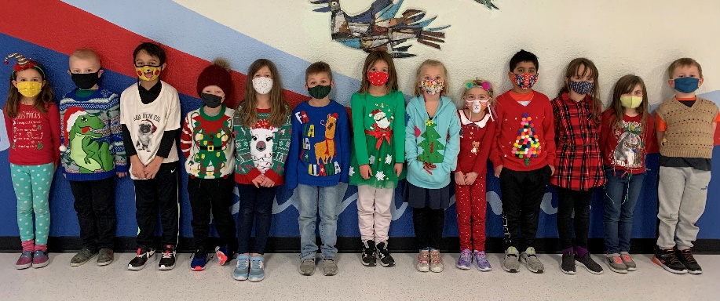

Christmas Theme Weeks

Christmas abounds for the next three and a half weeks. This first photo is grade 1 students that participated in crazy sweater week.

This photo is some of our grade 4 students that are sporting a stylish Christmas / winter cap with some tacky sweaters also.

GENEROSITY OF CAMPBELLTOWN

Some students from grade 3 showing off all the food and requested products donated by families for the Strathcona Food Bank.

There was also, food, gifts and gift cards that have been purchased for ten Campbelltown families that have needs for a variety of reasons. Through your cash donations, this was made possible. This is the second year we have done this. This is coordinated by Mme Boswell and student leaders via online shopping this year.

There was a total of $8000 donated for these hampers. Way to go Campbelltown! 😊

